ASSIGNMENT 4
ESTIMATE EFFORT AND SCHEDULE
CSE 7315
PLANNING AND MANAGING A SOFTWARE PROJECT

Spring, 2015

Professor Dennis J. Frailey

NAME __Rutuja Mandhare______ LOCATION ___On Campus
THIS COVER SHEET SHOULD APPEAR AS THE FIRST PAGE.

Grading template Student do not write inside this box

__________/45 1.0 Effort
__________/ 2.5 Overview and Comments
__________/ 2.5 Equivalent Size Table
__________/ 15 Key Parameters and Assumptions table
__________/ 15 Key Values Calculated table
__________/ 10 Cocomo Adjustment Factors table

___________/50 2.0 Schedules
__________/ 2.5 Overview and Comments
__________/ 2.5 Process Distribution by Phase
__________/ 15 Generic Schedule
__________/ 20 Effort Schedule
Schedule, Headcount Graph Before Adjustments,
Headcount Graph After Adjustments
__________/ 10 Additional Tasks included in Total Effort
___________/ 5 Overall Report Format

___________/100 Total Assignment Grade

Table of Contents
Overview and Comments 2
Equivalent Size Table 3
Key Parameters and Assumptions table 4
Key Values Calculated table 4
Cocomo Adjustments factors table 5
2.0 Schedules 7
Overview and Comments 7
Process Distribution by Phase 7
Generic Schedule 8
Effort Schedule 8
Headcount Graph Before Adjustments 9
Headcount Graph After Adjustments……………………………………………………….9

1.0 Effort

Overview and Comments

The effort is taken from the Equivalent size table which is measured in Lines of Code. The Base effort is found out by two ways. One is by Cocomo model and other one is productivity which uses the LOC for each language. The effort is calculated in staff months.

Equivalent Size Table

SOFTWARE ITEM : | NEW | COTS/REUSED CODE |  |  | MODIFIED CODE |  |  | NET
SOFTWARE ITEM : | CODE | SLOC or Function Pts. |  |  | SLOC or Function Pts. |  |  | EQUIV.
SOFTWARE ITEM : | (SLOC or |  |  |  |  |  |  | SIZE | C | JAVA | Python
PROCESSOR #1 | Function |  |  |  |  |  |  |  | C | JAVA | Python
PROCESSOR #1 | Points) | ORIGINAL | EQUIV. | EQUIV. | ORIGINAL | EQUIV. | EQUIV. |  | C | JAVA | Python
COMPONENTS |  |  | RATIO |  |  | RATIO |  |  | C | JAVA | Python
PROCESSOR #1 | 11000 | 93371 | 0.3 | 28011 | 12199 | 0.6 | 7319.4 | 46330 | 46330 | 0 | 0
PROCESSOR #2 | 21667 | 101250 | 0.02 | 2684 | 5000 | 0.6 | 3000 | 27351 | 2684 | 0 | 24667
PROCESSOR #3 | 5000 | 106570 | 0.02 | 3621 | 5000 | 0.6 | 3000 | 11621 | 11621 | 0 | 0
PROCESSOR #4 | 0 | 104826 | 0.02 | 2096 | 0 | 0.6 | 0 | 2096 | 2025 | 0 | 71
Total | 37667 | 101504 |  | 36412 | 22199 |  | 13319 | 87398

Key Parameters and Assumptions table
Key Parameters and Assumptions
Parameter | Initial Value | Final Value  (see Note) | Assumptions, Comments on Values Used
Cocomo Mode  (see Appendix A) | Embedded | Embedded | As there are many languages used many components and dependency on different departments so it is considered as Embedded.
Productivity Ratio  (Lines of Code/Day)  Python  C  Java | 12  8  10 | 13  8  11 | The productivity is increased to meet the deadlines.
Availability  (Staff Days per Month)  (Average, including  vacations, holidays) | 19 | 19 | As per the cost memo it is 19 days in a month.
 |  | 87398

Key Values Calculated table

Key Values Calculated
Value | Initial | Final | Comment on why Final is Different
Base  Schedule  Length | 12.97 months | 14.90 months | Schedule reduced slightly due to paralle development of some components
Adjusted  Schedule |  | 19.37 months | 30% add-on for requirements analysis& integration support
Base Effort  (from  productivity) | 1568 staff  days | 1393 staff  Days | Productivity raised so effort reduced
Base Effort  (from  Cocomo) | 419 staff  months | 624 staff  Months | Experience and complexity factors  increased after consultation with staff experts
Adjusted  Base Effort |  | 748 staff  month | 20% add-on for  requirements analysis
Total Effort |  | 972 staff  months | 224 staff months for SWCM, SWQE, and SW Management
Grand Total  Labor |  | 2212 staff  Days | 200 staff days for IV&V and misc.
Grand Total  Cost |  | $420,911 | Includes travel and  software costs

Nominal effort = f ∗ (( KLOC)e1)

= 1.9((87.3)1.20)

= 405.48

Base Effort = 1.54* 405.48
= 624.44

Effort Adjustment Factor = 1.54

Adjusted Base Effort = 748

Software Configuration Management Effort =5% * Adjusted Base Effort
= 37
Software Project Management Effort = 15% * Adjusted Base Effort
= 112

Quality Assurance Effort = 10% * Adjusted Base effort
= 75

Normal schedule = 1.9 * ((405.48)0.32)
= 1.9* ((405.48)0.32)
=12.97

Base Schedule = 1.9* ((624.44)e2)
= 1.9* ((624.44)0.32)
=14.90

Cocomo Adjustments factors table

Cocomo Adjustment Factors
Factor | Initial Value | Final Value |  | Rationale
Product Attributes
RELY- Required Reliability | 1 | 1.3 | Reliability very important
DATA- Data base size | 0.7 | 0.7 | There is no database
CPLX- Product Complexity | 1.3 | 1.8 | There are many software items and different languages are used
RUSE-Required Reuse | 1.25 | 1.8 | There are some components
Computer Attributes
STOR-Memory Storage Contrains | 1.0 | 2.0 | Memory and Storage are primary perspective
VHVH-Host Virtual Machine Volatility | 1.0 | 0.9 | Not more of Virtual Memory is needed
VMVT-Target Virtual Machine Volatility | 1.0 | 0.9
TIME- Exécution. Time Contraints | 1.0 | 1.6 | Any delay in the transfer of data would lead to mishap.
TURN- Turnaround Time for Développements Tools | 1.0 | 1.4
Personnel attributes
AXEP- Analyst Expérience | 1.0 | 1.9 | Experience is more important which plays an important role
ACAP- Analyst Capability | 1.0 | 1.85 | Task to be completed on time
PCAP- Programmer Capability | 1.0 | 1.9 | Effective programming can be accomplished just with software engineers capacity
VXEP-Team Expérience with this Virtual machine | 1.0 | 1.0 | Experience is needed to handle things
LXEP-Team Expérience with this program ming lagunage | 1.0 | 2.0 | There are different languages and without experience it cant be achieved.
Project Attributes
TOOL-Modern Tools | 1.0 | 1.6 | Modern tools provide better result
MOOP-Modern Practices | 1.0 | 1.8 | Modern tools provide better results and efficiency
SECU-Security Requirements | 1.0 | 1.5 | Security is very important in all aspect
SCEO-Schedule Constraints | 1.0 | 1.9 | Meeting schedule is very important.
EFFORT  ADJUSTMENT  FACTOR | 1.033 | 1.54

2.0 Schedules

Overview and Comments
Once the effort is computed, the schedule is calculated by cocomo model using the formulas specified previously. Once, the effort schedule is arranged for every month, the Add-ons are added to every months so that the Headcount is practical and achievable.

Process Distribution by Phase

Process Distribution by Phase
Phase | % of  Adj. Base  Effort | Approximate  % of Adjusted  Schedule (1) | Effort  (staff  days) (2) | Comment on Values Used
Requirements | 17% | 20% | 2842 | There are many requirements and some are being utilized from past stage
Top Level Design | 10% | 15% | 2131 | Top level design takes more time so schedule has increased.
Detailed Design | 15% | 15% | 2131
Code & Unit Test | 23% | 20% | 2842 | Productivity is somewhat expanded so schedule has been decreased
Integration | 15% | 15% | 2131
Configuration Management | 10% | 5% | 710 | Configuration Man agement System is used to manage changes.
Quality Assurance | 10% | 10% | 1421
TOTAL | 100% | 100% | 14212

Generic Schedule

8788888888888888

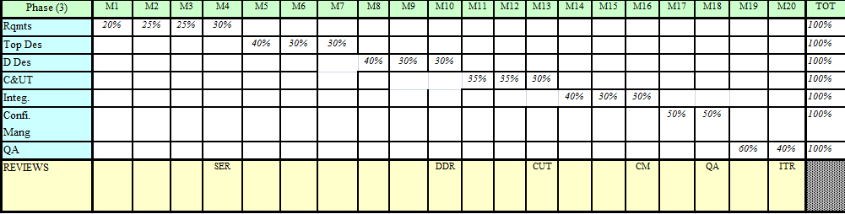

Effort Schedule

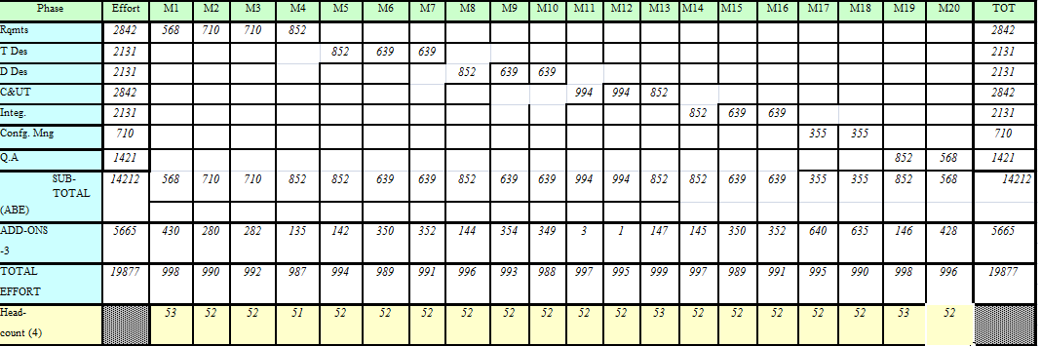

Headcount Graph before Adjustments

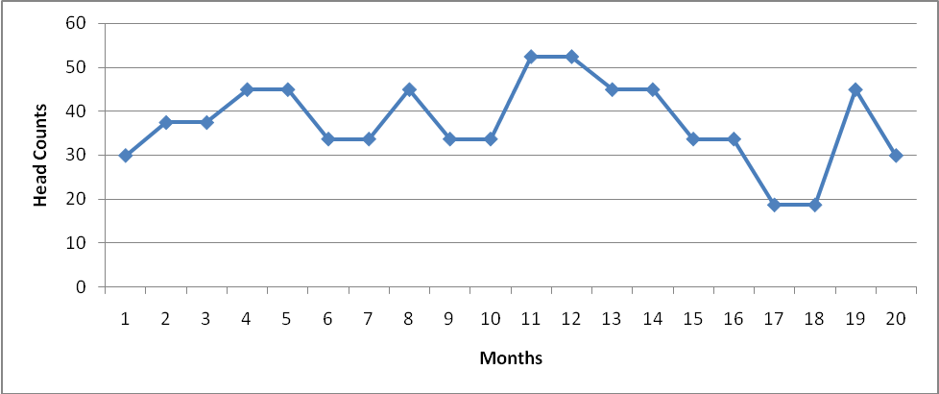

Headcount Graph after Adjustments

